Contents
Context 1
Viewing data sources 2
Database connection 2
Login credentials 2
Amending data sources 4
Database connection 5
Login credentials 5
Adding data sources to reports 7
Removing data sources from reports 8

Additional Guidance
Knowledge Article: not yet written
HOW TO - Manage Reports - Access Permissions within HR Reporting.docx
HOW TO - Manage Reports - Change Processes in OSM.docx
HOW TO - Manage Reports - HR Reporting Environments.docx
HOW TO - Manage Reports - Parameters.docx
HOW TO - Manage Reports - Release and Deployment.docx
HOW TO - Manage Reports - Shared Datasets.docx
HOW TO - Manage Reports - Troubleshoot Common Errors.docx
HOW TO - Manage Reports - Visual Studio Basics.docx

Context
A data source is technically the source of the data which is returned by a report query, i.e. the PeopleXD database which powers your reports (UOXC, UOXP, etc.). In Visual Studio, though, the term “data source” refers to something more like a connection profile – it’s where you both define which PeopleXD database you’re going to use, and provide the login credentials for accessing that database.
There are two shared data sources held in all of the HR Reporting Visual Studio solutions and used across the majority of reports:
- Oracle_DS_ServiceAccount: This data source is linked to a PeopleXD service account rather than a standard user account. It is primarily used to run the SQL queries for the shared datasets which populate report parameters, e.g. to retrieve all department codes for use in a parameter’s drop-down list.
- Oracle_DS_UserCredentials: This data source relies on each user’s individual reporting login credentials. When a user enters their credentials and runs a report, the PeopleXD database will automatically apply the correct user security to the data when retrieving the report results; e.g. a user who is only allowed to see Pay Group 20 will only see results for Pay Group 20.

Viewing data sources
To view a shared data source, go to the Solution Explorer pane in your Visual Studio solution and expand the Shared Data Sources folder. You will be presented with a list of data sources currently available within the solution.

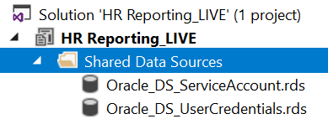

Double-click or right-click the data source you wish to view and select Open from the menu:

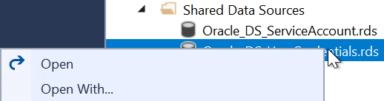

The Shared Data Source Properties window will open and the General screen will be displayed.

Database connection
The “Connection String” field will show you which PeopleXD database the current Visual Studio solution is connected to, e.g. UOXZ, UOXC, UOXU or UOXP. This is the database from which all reports in the current solution will retrieve their data:

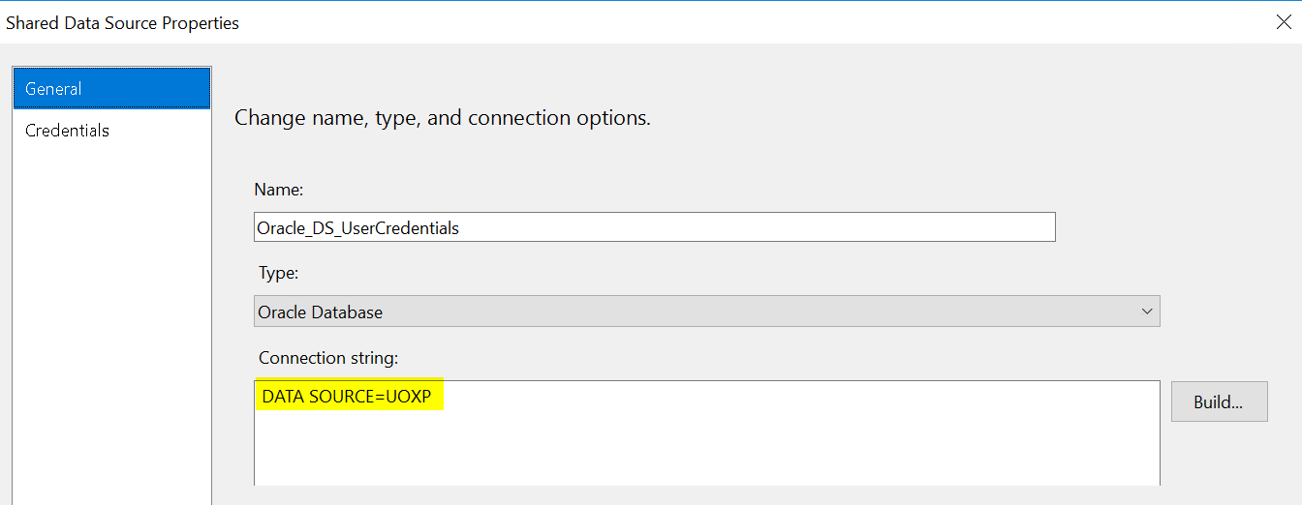

Login credentials
Each data source connects to PeopleXD by logging into the database specified in the “Connection String”. This means that login credentials must be supplied to the data source.
To check the login credentials for a data source, click Build… next to the “Connection String” field:
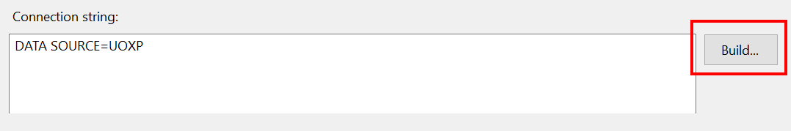

The Connection Properties window will pop up. This window will confirm which PeopleXD database the data source is using in the “Server name” field, along with the login credentials being used to access that database. You can check whether the data source is able to access the database with the login credentials provided by clicking “Test Connection”:

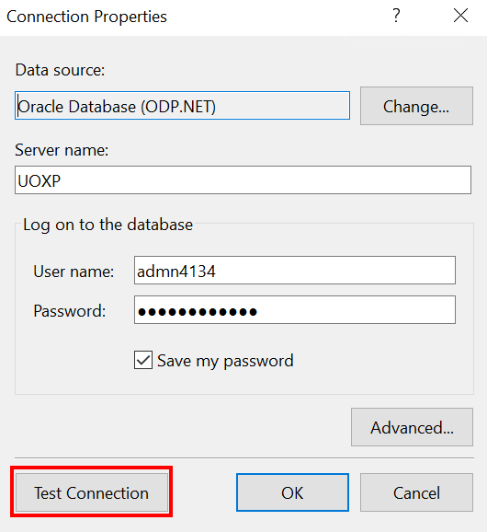

Visual Studio will supply the login credentials to PeopleXD and confirm whether the database is accessible:

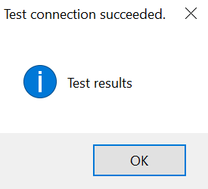

If you have entered invalid login credentials, the connection test will fail when Visual Studio attempts to access the PeopleXD database:

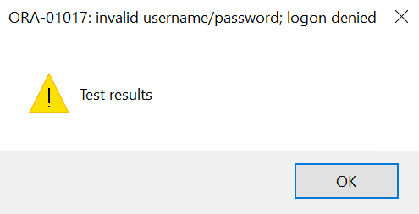

Double-check the username and password you’ve entered and try testing the connection again. If you are still unable to connect to the PeopleXD database, a couple of things might be happening:

- The PeopleXD reporting database is unavailable – the databases occasionally become uncontactable, for instance during system maintenance. If this is the case, nobody should be able to log into the reporting database in question. Speak to another HR Reporting Visual Studio user and ask them to test their connection to the same data source. If they are able to connect to the data source and you still can’t, you probably need to reset your password.
- Your HR Reporting password has expired – if this is the case, you will need to contact the HR Systems Support team and get your HR reporting password reset. Be sure to specify which PeopleXD database you are trying to access, so that your password can be reset in the correct environment.

Amending data sources

Amending in Visual Studio

 | NB: If you have reset your HR Reporting password, you will need to update it in the Oracle_DS_UserCredentials data source.

If you need to amend a data source in Visual Studio, go to the Solution Explorer pane in your Visual Studio solution and expand the Shared Data Sources folder.



Select and open the shared data source you wish to amend. The Shared Data Source Properties window will open and the General screen will be displayed.

Click Build… next to the “Connection String” field to open the Connection Properties window:

You can now edit the data source’s database connection or login credentials as required.

Database connection
To amend the database connection for a data source, update the value in the “Server name” field to indicate which PeopleXD database you wish to connect to.
- Example: If your data source previously connected to the UOXU database and you want it to connect to UOXP, enter “UOXP” in the “Server name” field:
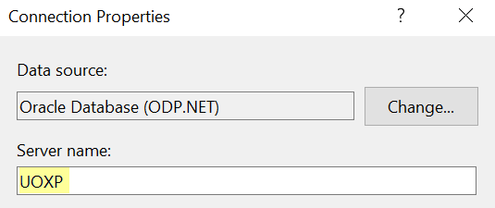

Supply the relevant login credentials and click “Test Connection” to check that you are able to access the new database.



Login credentials
To update the login credentials for a data source, amend the values in the “User name” and/or “Password” fields:

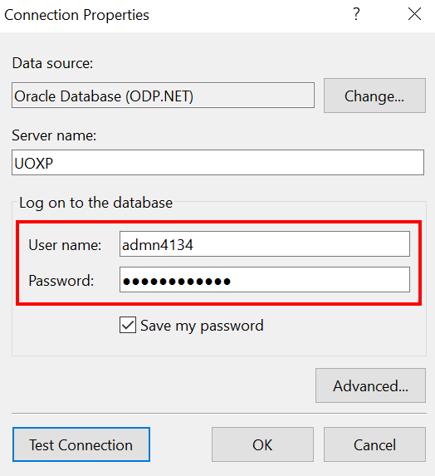
Click “Test Connection” to check that you are able to access the database with the new login credentials.

NOTES: The UserCredentials data source
For the Oracle_DS_UserCredentials data source, the login credentials can be set to your personal reporting login details – this will enable you to run your report in the Preview pane without having to provide your username and password every time you want to run queries in Visual Studio.
Just enter your login details in the Connection Properties window and select “Save my password” to store your password for the duration of your Visual Studio session.

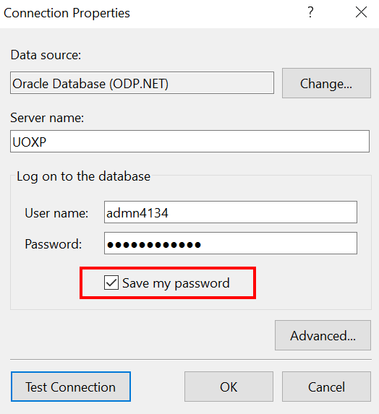

NOTES: The ServiceAccount data source
For the Oracle_DS_ServiceAccount data source, the login credentials are the same across all Visual Studio solutions and the “Save my password” option is selected in each instance so that the login credentials don’t need to be refreshed:

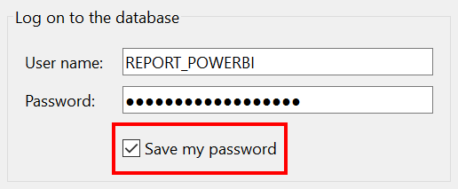

If for whatever reason you need to re-enter the login credentials for the ServiceAccount data source, the username is “REPORT_POWERBI”. See the note about the password below.

 | NB: The Service Account has unlimited user sessions and unrestricted access to PeopleXD’s databases, so it must be kept highly secure to prevent unwanted data breaches. Only a subset of reporting super-users (Athena Artuso and Simon Burford) know the login credentials for the ServiceAccount data source, and they must periodically update these login credentials to keep the account secure.  If you need to add the password for the Oracle_DS_ServiceAccount data source to your Visual Studio solution, you must contact Athena or Simon and ask them to update the data source for you.

Amending on the SQL Server
Once the data sources have been amended in Visual Studio and you have checked that the change has worked you can make the change on the SQL Server. To do this you must not attempt to redeploy the data source from Visual Studio, instead make the changes manually.
To do this, navigate to the Data Sources folder on the SQL Server (you may need to display hidden folders if you haven’t already):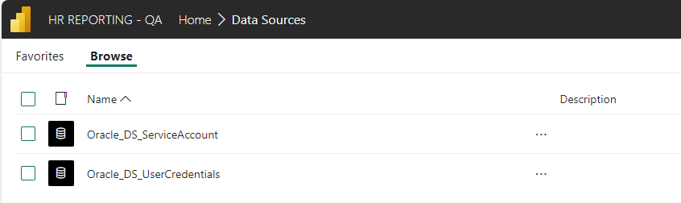

For each data source, click on the ellipsis and select “Manage”: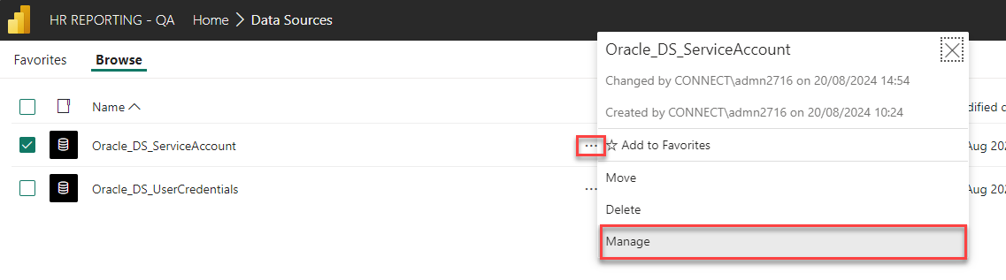
Amend the database name within the connection string: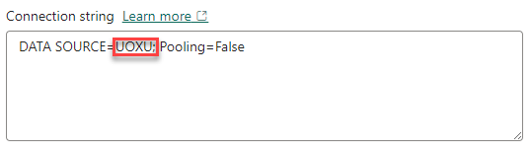
You may also need to enter the credentials if you are amending the Oracle_DS_ServiceAccount data source, if so, test that you have entered them correctly.

Finally click on the “Apply” button at the bottom of the screen.

Updating the HRIS Launcher
If you have re-pointed an SQL server to a different PeopleXD environment you should update the text on the HRIS Launcher page which explains which PeopleXD environment each HR Reporting environment is pointed at:
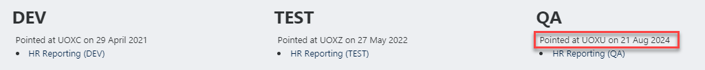
To alter this, open Notepad++ and open:
O:/PS/HR Systems/Support/Infrastructure/HRIS Launcher/HRIS_launcher.html
Search for the HR Reporting Environment to amend, you can search for the following phrase to search for the QA environment, for example:
<!-- Pointing Dates for QA -->
When you have updated the environment and the date you made the change, update the date the page was updated and save your changes. You can find the last updated date by searching for the following phrase:
<!-- last updated on -->

Adding data sources to reports
Most .RDL files in Visual Studio must contain the two standard shared data sources: the ServiceAccount source and the UserCredentials source.

To check which data sources are attached to your .RDL file, go to the Report Data pane on the left side of the screen and open the Data Sources folder:

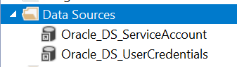

If you are missing either data source, simply right-click the Data Sources folder and select Add Data Source….

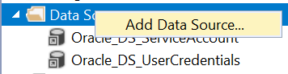

The Data Source Properties window will open. Select the radio button to “Use shared data source reference” and select the appropriate data source from the drop-down menu:

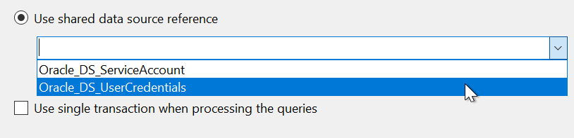

Edit the “Name” field to match the name of the shared data source:

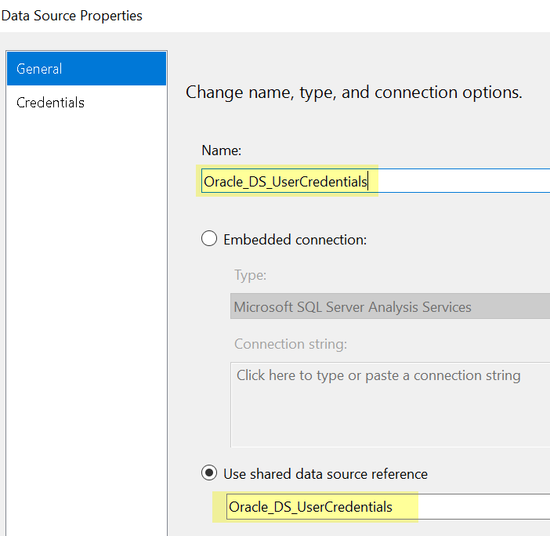

Click “OK” to confirm your change. Remember to click the “Save” icon before closing your .RDL file or your changes won’t be saved!

Removing data sources from reports
It is highly unlikely that you will ever need to remove a data source from a report, however if you do need to, go to the Report Data pane on the left side of the screen and open the Data Sources folder:



Right-click the data source you wish to remove and click “Delete”:

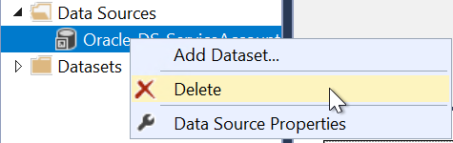

Save your changes before closing the .RDL file.

The exceptions to this rule are “subscription-based” reports, which only use the Oracle_DS_ServiceAccount data source. There are very few subscription-based reports, so as a rule, any reports you work on in Visual Studio should include both the ServiceAccount and the UserCredentials data sources. You can read more about subscription-based reports in the how-to guide for managing access permissions within HR Reporting.

